2020 02 08 NR Daily Log

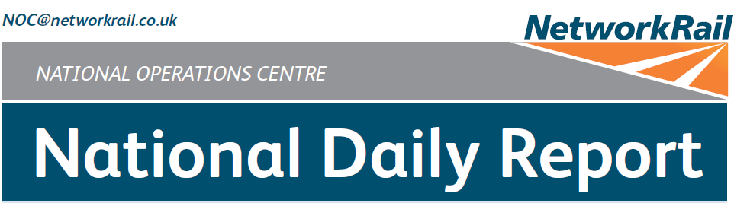



***DATE OF REPORT: NOC MANAGER 0700 – 1900:***

***NOC MANAGER 1900 – 0700:***

***DUTY CONTROLLER 0630 – 1830:***

***DUTY CONTROLLER 1830 – 0630:***

***SUPPORT CONTROLLER 0630 – 1830:***

***SUPPORT CONTROLLER 1830 – 0630:***

***LONDON CONTROLLER 0700 – 1900:***

***LONDON CONTROLLER 1900 – 0700:***

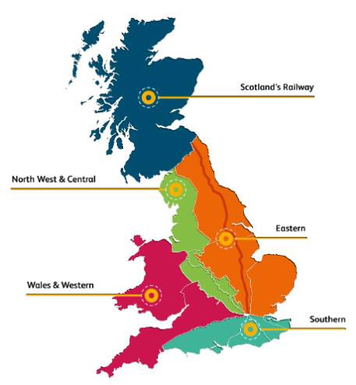

Saturday 08th February 2020 Lucinda Wing

Matthew Whitfield Bob Scoot

Mark Robinson Peter Ure

Jo Billson Dominic Duggan Keith Stokes

# TABLE OF CONTENTS

1. WRONG SIDE FAILURE REPORTS 3
2. SIGNALS PASSED AT RED (CATEGORY ‘A’) 3
3. DERAILMENTS 3
4. COLLISIONS 3
5. TRAIN OR VEHICLE RUNAWAY 3
6. OPERATIONAL INCIDENTS 4
7. TRAINS WITH STRANDED PASSENGERS 4
8. SIGNIFICANT POSSESSION PROBLEMS 4
9. FATALITIES 4
10. INJURIES/ASSAULTS 4
11. NEAR MISSES 5
12. RAILWAY CRIME 5
13. STATION OVERRUNS 5
14. BROKEN RAILS/TRACK DEFECTS 6
15. POWER FAILURES 6
16. POINTS FAILURES 6
17. SIGNALS/SIGNALLING SYSTEMS FAILURES 6
18. TRACK CIRCUIT & AXLE COUNTER FAILURES 7
19. BRIDGE STRIKES 7
20. ROAD VEHICLE INCURSIONS (NON-LEVEL CROSSINGS) 7
21. TRACTION FAILURES 8
22. WEATHER-RELATED PROBLEMS 8
23. FIRES 8
24. WILD REPORTS & HABD ACTIVATIONS 9
25. GROUP STANDARDS GE/RT8250 & GO/RT3350 10
26. TPWS 10
27. MISCELLANEOUS 10
28. REVIEW TABLE 11
29. REAL TIME PERFORMANCE FIGURES 12

## North West and Central (North West) - CCIL 2090887

***01 WRONG SIDE FAILURE REPORTS***

At 1442, the driver of 1P77, TransPennine Express, 1340 Manchester Airport - Redcar Central, reported that signal DE25 on the Down Huddersfield line at Diggle Junction had reverted from green to a single yellow aspect. The signaller reported that DE25 signal should have been displaying a single yellow aspect as the next section was occupied by 9S13, TransPennine Express, 1324 Liverpool Lime Street – Edinburgh Waverley. S&T were advised at 1445, arriving on site at 1559. Non-destructive testing was completed by 1835, with destructive testing due to be carried out after service. The results of which were outstanding as this Report closed.

|  |  |  |  |  |  |  |  |
| --- | --- | --- | --- | --- | --- | --- | --- |
| TRUST 762502 IQFM | | | | | | | |
| Cancelled | 0 | Part Cancelled | 1 | Trains Delayed | 101 | Minutes | 695 |

***02 SIGNALS PASSED AT RED (CATEGORY ‘A’)***

## Wales and Western (Western) – CCIL 2090657

At 1042 5Z16, Rail Operations Group, 1114 Barton Hill Depot – Neville Hill Depot, passed the stop board on the departure line at Barton Hill Depot, stopping on approach to BL6628 GPL signal, which leads onto the Up Filton Relief line, causing signals to revert to danger. The Stop Board instructs the driver to not pass until the signal has been cleared. When questioned, the driver stated that they had been given permission to move up to the signal by the shunter (group 2 cause). After consultation with Rail Operations Group, the driver was judged unfit to continue and the train was returned to the depot.

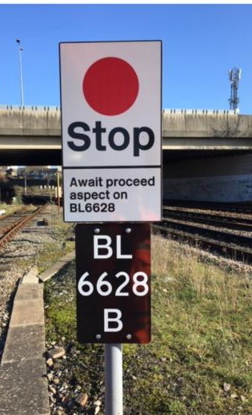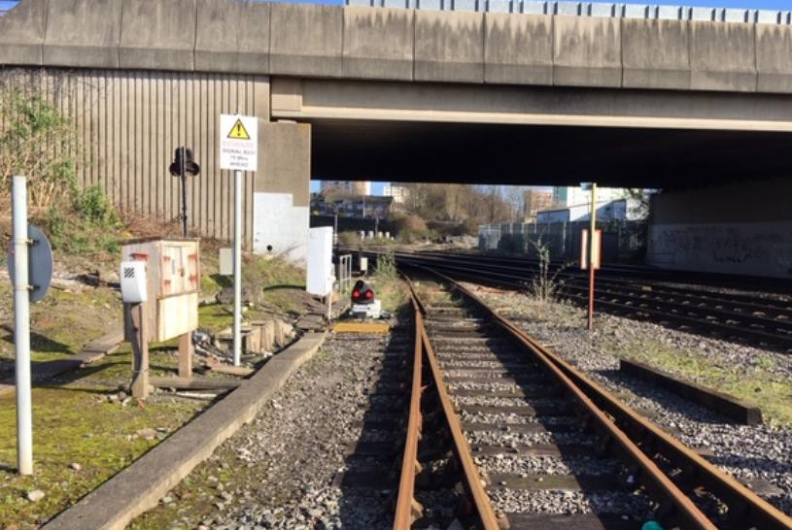

|  |  |  |  |  |  |  |  |
| --- | --- | --- | --- | --- | --- | --- | --- |
| TRUST 762056 FPHA | | | | | | | |
| Cancelled | 1 | Part Cancelled | 0 | Trains Delayed | 9 | Minutes | 48 |

***03 DERAILMENTS***

None.

***04 COLLISIONS***

None.

***05 TRAIN OR VEHICLE RUNAWAY***

None.

None.

***07 TRAINS WITH STRANDED PASSENGERS***

|  |  |  |  |  |  |
| --- | --- | --- | --- | --- | --- |
| ***Region / Route*** | ***Train*** | ***Since*** | ***Between*** | ***OUTCOME*** | ***CCIL*** |
| NW&C (NW) | 2U56, Merseyrail Electrics, 1928 Southport – Hunts Cross | 2007 -  2100 | Sandhills - Moorfields | Train came to as stand due to a trespasser. The individual was detained, and train proceeded forward after the traction current was recharged | 2091024 |
| NW&C (NW) | 2S57, Merseyrail Electrics, 1951 Hunts Cross - Southport | 2006 -  2100 | Brunswick – Liverpool Central | Train came to as stand due to a trespasser. The individual was detained, and train proceeded forward after the traction current was recharged. | 2091024 |

***08 SIGNIFICANT POSSESSION PROBLEMS***

None.

***09 FATALITIES***

None.

***10 INJURIES/ASSAULTS***

## Eastern (North & East) – CCIL 2090954

At 1643, BT Police (ref. 410) advised that they had received a report of a person on the line at Frizinghall. A following service was cautioned, with nothing amiss reported at 1658. However, at 1704 the driver of 2D69, Northern, 1621 Ilkley – Bradford Forster Square, reported a person leaning against the stanchion at Bridge 3, Wharncliffe Road. Concurrently the Mobile Operations Manager, appointed RIO, BT Police (ref. 410) and the West Yorkshire Police (ref. 1237) arrived on site, with the RIO advising that the person appeared to be intoxicated and had sustained an injury to their ankle. In response, all lines were blocked. The person advised that they had fallen and in doing so caused the injury to themselves. The Down line was opened at caution at 1733, with the person contained to the Up side. An ambulance was on site at 1749, with the person removed from the line and into their care at 1802. Trains were signalled normally from 1804, after it was confirmed that all personnel were clear of the line.

|  |  |  |  |  |  |  |  |
| --- | --- | --- | --- | --- | --- | --- | --- |
| TRUST 762723 XQGL | | | | | | | |
| Cancelled | 9 | Part Cancelled | 18 | Trains Delayed | 76 | Minutes | 1039 |

## Southern (Sussex) – CCIL 2091122

At 0046 the driver of 2C77, Govia Thameslink Railway, 2353 Seaford – Brighton formed by unit 377703, reported that a passenger had fallen between the platform and train in platform 7 at destination whilst egressing the service, after bumping into another passenger. An ambulance was sent to site to assess the injured party.

## Southern (Wessex) – CCIL 2090803

At 1115 the driver of 2P23, South Western Railway, 0945 London Waterloo – Portsmouth & Southsea, reported a near miss at Liss Forest FP crossing, between Liss and Liphook, with a person with a dog standing on the Up line on the crossing as the train passed on the Down line. The driver was fit to continue.

## Scotland – CCIL 2090939 / Fault No. 349245

At 1639 the driver of 2H62, ScotRail, 1234 Wick - Inverness, reported a near miss at Foulis R/G Level Crossing between Alness and Dingwall with a road vehicle. The driver was fit to continue and following services were cautioned. A Mobile Operations Manager was sent to site, reporting both crossing gates closed and secured at 1810, thus allowing trains to be signalled normally. The BT Police (ref. 411) were advised.

|  |  |  |  |  |  |  |  |
| --- | --- | --- | --- | --- | --- | --- | --- |
| TRUST 762724 XQLU | | | | | | | |
| Cancelled | 0 | Part Cancelled | 0 | Trains Delayed | 2 | Minutes | 10 |

***12 RAILWAY CRIME***

## North West and Central (NW) – CCIL 2091024

At 2006, it was reported that a person had been observed to run into the single bore tunnel at Moorfields from platform 2 towards Leeds Street Junction. In response, an emergency switch-off was effected by Sandhills ECR, which initially affected Wirral and Northern lines. This resulted in two services becoming trapped between stations (detailed in section **07** of this Report). At 2022 the Wirral line was re-energised. The Northern Mobile Operations Manager was on site at 2030 and inspected the area from Moorfields to Leeds Street Tunnel, with no person found. The Mobile Operations Manager reported at 2047, that upon meeting the BT Police (ref. 595) at Leeds Street Tunnel, they reported seeing no persons in the area. All lines were re-energised, thus allowing trains to be signalled normally.

|  |  |  |  |  |  |  |  |
| --- | --- | --- | --- | --- | --- | --- | --- |
| TRUST 763106 XQFM | | | | | | | |
| Cancelled | 6 | Part Cancelled | 14 | Trains Delayed | 25 | Minutes | 694 |

***13 STATION OVERRUNS***

## Southern (Wessex) – CCIL 2090733

At 0850, 2U17, South Western Railway, 0812 London Waterloo – Windsor & Eton Riverside, formed by units 707025 and 707010, comprising ten coaches in all, overran Syon Lane station by ½ a coach length. It was advised that one door was not accommodated in the platform, with selected door opening utilised. The driver stated that the overrun was due to a loss of concentration and braking slightly late. The driver was fit to continue to Staines where they were relieved of duty.

|  |  |  |  |  |  |  |  |
| --- | --- | --- | --- | --- | --- | --- | --- |
| TRUST 761893 THYP | | | | | | | |
| Cancelled | 0 | Part Cancelled | 0 | Trains Delayed | 1 | Minutes | 5 |

***14 BROKEN RAILS/TRACK DEFECTS***

## North West and Central (NW) – CCIL 2090961

At 1720, the driver of 1H36, Avanti West Coast, 1620 London Euston – Manchester Piccadilly reported a rough ride on the Down Main line at Hillmorton Junction. 1S82, Avanti West Coast, 1630 London Euston

– Glasgow Central was utilised to examine the line, reporting nothing amiss at 1726. P’Way staff were on site at 1810 and began investigations between services, with the Rugby Mobile Operations Manager sent to site to assist. Some services were diverted via Northampton to ease congestion. P’Way advised at 1903 that KR331 points were identified as sitting low but still within tolerance. 9K94, Avanti West Coast, 1843 London Euston - Crewe was utilised to examine the line, with the driver reporting a left to right movement through the affected section whilst travelling at 60 mph. P’Way staff were afforded a Line Blockage at 2030 to undertake lifting at packing, with all affected services diverted via Northampton. The Line Blockage was cancelled at 2132, due to a fault with their jack hammer. Services were reinstated at caution, with P’Way staff returning to the depot for replacement equipment and more resources. Works were on going at the close of this report.

|  |  |  |  |  |  |  |  |
| --- | --- | --- | --- | --- | --- | --- | --- |
| TRUST 762719 IQNA | | | | | | | |
| Cancelled | 0 | Part Cancelled | 0 | Trains Delayed | 146 | Minutes | 1323 |

***15 POWER FAILURES***

## Scotland – CCIL 2090959 / Fault No. 349248

At 1713, Cathcart ECO reported that OLE section DH2 had tripped and was subsequently reset with 2H53, ScotRail, 1522 Edinburgh Waverley – Helensburgh Central in section at Cardross. OLE section DH2 tripped multiple times between 1718 and 1735. The signaller advised at 1740, that ‘245’ axle counter at Craigendoran Junction had failed, but they were able to switch to DC track circuit which then showed clear. Concurrently OLE section DH1 & DH2 both tripped, with the ECO advising that they would not attempt a reset. Services were terminated at Dalreoch and services were terminated/started at Hyndland. A following service examined the line at 1847 and reported that no obvious issues with the OLE, however, sea spray was coming over the sea wall. OLE staff were sent to site and were afforded a Line Blockage at 2140, reporting at 2228 that there were no issues identified with the OLE between Cardross and Craigendoran. OLE section DH2 was re-energised at 2245, with OLE section DH1 planned to be examined within a planned possession. The results of which were outstanding at the close of this Report.

|  |  |  |  |  |  |  |  |
| --- | --- | --- | --- | --- | --- | --- | --- |
| TRUST 762739 XQLY | | | | | | | |
| Cancelled | 3 | Part Cancelled | 25 | Trains Delayed | 38 | Minutes | 331 |

***16 POINTS FAILURES***

## Eastern (EM) – CCIL 2090977

At 1755 the driver of 1K23, East Midlands Railway, 1742 Derby - Crewe, reported that DY304 signal on the Down Tamworth line at North Stafford Junction had reverted from green to red as the train approached. The driver was unable to stop and passed the signal at red. The reason for the reversion was due to a momentary loss of detection on No. 679 points. The driver was fit to continue.

|  |  |  |  |  |  |  |  |
| --- | --- | --- | --- | --- | --- | --- | --- |
| TRUST 762858 IQVN | | | | | | | |
| Cancelled | 0 | Part Cancelled | 0 | Trains Delayed | 2 | Minutes | 30 |

***17 SIGNALS/SIGNALLING SYSTEMS FAILURES***

None.

***18 TRACK CIRCUIT & AXLE COUNTER FAILURES***

## Eastern (EM) – CCIL 2090505 / Fault No. 153984

With reference to an item detailed in this section of yesterday’s Report regarding the failure of ‘134’ track circuit at Kentish Town: the TPIC advised at 0205 that rodent damage had been caused to the cabling within the troughing. The cable was re-terminated and following testing the fault was signed back in order at 0318, thus allowing trains to be signalled normally.

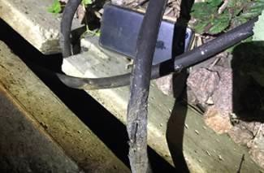

## Southern (Wessex) – CCIL 2090810

At 1120 “BBU” track circuit on the Down Fast line at Basingstoke failed after the passage of a train, locking a route from the Down Reading line into platform 2, preventing the use of the Up Slow and Up Fast lines, and the Main lines through platform 2, with drivers on other routes requiring to be authorised affected signals at red. A Mobile Operations Manager, P’Way and S&T staff were sent to site. Service levels were reduced with services held at Reading. Other services were diverted via Havant or terminated short of destination. A previous fault in the area showed that tie bars had been fitted on No. 2521 points, which the track circuit runs through, with the Mobile Operations Manager directed to inspect the points. At 1153 the Mobile Operations Manager reported a loose tie bar on the points. The tie bar was moved and the track circuit and route lock cleared, allowing normal signalling. The Mobile Operations Manager secured the points in the Normal position to prevent a recurrence of the fault, pending P’Way staff attention to the tie bar and insulation. The tie bar and insulation was attended to by 1312, however, two other tie bars were found to be loose which were attended to by 1320. Arrangements were made for the tie bars to be regularly inspected.

|  |  |  |  |  |  |  |  |
| --- | --- | --- | --- | --- | --- | --- | --- |
| TRUST 762133 IQCZ | | | | | | | |
| Cancelled | 3 | Part Cancelled | 4 | Trains Delayed | 53 | Minutes | 626 |

***19 BRIDGE STRIKES***

|  |  |  |  |  |  |  |  |
| --- | --- | --- | --- | --- | --- | --- | --- |
| ***Region / Route*** | ***Time*** | ***Location*** | ***Bridge No.*** | ***Dispensation*** | ***NWR*** | ***CCIL*** | ***TRUST*** |
| NIL |  |  |  |  |  |  |  |

***20 ROAD VEHICLE INCURSIONS (NON-LEVEL CROSSINGS)***

None.

***21 TRACTION FAILURES***

## Wales and Western (Wales) – CCIL 2090668.

At 0440 6B13, DB Cargo, 0500 Robeston - Westerleigh, formed by 28 loaded tank vehicles = 2705 tonnes hauled by locomotive 60062, stopped out of course at Clarbeston Road with a loss of power on the locomotive. The train went forward at 0505, but experienced further power losses and came to a stand near Whitland tunnel, from where the driver declared the locomotive a failure at 0558. An assisting locomotive was despatched from Margam at 0711 and attached to the failed train at 0855. 6B13 was assisted to destination at 0907.

|  |  |  |  |  |  |  |  |
| --- | --- | --- | --- | --- | --- | --- | --- |
| TRUST 761475 MWAW | | | | | | | |
| Cancelled | 4 | Part Cancelled | 4 | Trains Delayed | 27 | Minutes | 566 |

## Scotland – CCIL 761626

At 0617, the Hilton Junction signaller advised that 4H47, Direct Rail Services, 0504 Mossend Up Reception

– Inverness had come to a stand between Auchterarder and Hilton Junction with a loss of power on locomotive 66303. The driver was unable to overcome the fault and declared the train a failure at 0644. A locomotive at Motherwell was identified to assist. At 0715, 4H47 was on the move again but only at 10 mph. The assisting locomotive, running as 1Z99, departed Motherwell at 0728. 4H47 came to a stand near Hilton Junction at 0806 and was once again declared a failure. At 0839, 1Z99 was cautioned onto the rear of 4H47, with the combined train on the move at 0904 towards Perth but was only able to proceed at 5 mph due to an electrical fault on the defective locomotive. 4H47 arrived at Perth at 0928, where the defective locomotive was detached. The assisting locomotive ran around the train, where it was attached to the front and departed at 1019, running 233 minutes late.

|  |  |  |  |  |  |  |  |
| --- | --- | --- | --- | --- | --- | --- | --- |
| TRUST 761626 MXHA | | | | | | | |
| Cancelled | 2 | Part Cancelled | 4 | Trains Delayed | 60 | Minutes | 770 |

## Scotland – CCIL 2090819

At 1123, the Shift Signalling Manager at Motherwell reported that 1M96, TransPennine Express, 1108 Glasgow Central – Manchester Airport formed by unit 397002, had come to a stand in the vicinity of Uddington due to a VCB. The driver was able to overcome the fault by switching pantographs. The train proceeded forward at 1125, however, came to a stand on two further occasions with the same fault. At 1234, the train came to a stand at Beattock summit. The driver performed a hard reset, clearing all faults and proceed forward at 1251. Significant delays ensued as a result.

|  |  |  |  |  |  |  |  |
| --- | --- | --- | --- | --- | --- | --- | --- |
| TRUST 762136 MEA4 | | | | | | | |
| Cancelled | 3 | Part Cancelled | 3 | Trains Delayed | 78 | Minutes | 802 |

***22 WEATHER-RELATED PROBLEMS***

None.

***23 FIRES***

None.

***24 WILD REPORTS & HABD ACTIVATIONS***

## Disconnected Hot Axle Box Detectors:

|  |  |  |  |  |  |  |  |  |  |
| --- | --- | --- | --- | --- | --- | --- | --- | --- | --- |
| *Region / Route* | *Location* | *Line* | *Date Disconnected* | *Reason* | *TOC’s/ FOC’s*  *advised* | *Planned Restoration Date* | *Date Restored* | *Function* | *Fault Number* |
| Eastern (Anglia) | Brentwood | Down Electric | 10/03/16 | Offline | Y | Awaiting update |  | IM | 234632 |
| Eastern (Anglia) | Brentwood | Down Main | 10/03/16 | Offline | Y | Awaiting update |  | IM | 234632 |
| Eastern | Margaretting | Up Main | 19/09/19 |  | Y | Awaiting update |  | IM | 298498 |
| Eastern (EM) | Chiltern Green | Down Slow | 11/07/19 | Defective | Y | Awaiting update |  |  | 148559 |
| Eastern (EM) | Napsbury | Up Fast | 11/07/19 | Defective | Y | Awaiting update |  |  | 148559 |
| Eastern (LNE) | Barkston | Up Main | 01/04/19 | Removed for P’Way work | Y | Awaiting update |  |  |  |
| NW & Central (NW) | Bolton-le- Sands | Up Main | 25/08/19 | Integrity Fault | Y | Awaiting update |  |  | 863361 |
| NW & Central (NW) | Hest Bank | Up Main | 25/08/19 | Integrity Fault | Y | Awaiting update |  |  | 863360 |
| NW & Central (NW) | Low Mill | Down Main | 26/11/14 | Awaiting replacement | Y | Awaiting update |  | IP | 671852 |
| NW & Central (NW) | Sutton Weaver | Down Main |  |  | Y | Awaiting update |  |  |  |
| NW & Central (WCMLS) | Bradnocks Marsh (Coventry) | Up Main | 29/12/19 | Integrity | Y | Awaiting Update |  |  | 872142 |
| NW & Central (WCMLS) | Castlethorpe | Up Fast | 27/11/18 | Error code 6.0 | Y | Awaiting Update |  | IM | 832410 |
| NW & Central (WCMLS) | Harecastle | Up Main | 01/04/19 | Rail incorrectly drilled | Y | Awaiting Update |  |  |  |
| NW & Central (WCMLS) | Penkridge | Up Penkridge | 04/11/19 | Integrity | Y | Awaiting Update |  |  | 870982 |
| NW & Central (WCMLS) | Spetchley |  | 29/12/19 | Integrity | Y | Awaiting Update |  |  |  |
| Wales & Western (Wales) | Dainton | Down Main | 17/11/19 | Defective PC | Y | Awaiting Update |  | IM | 453850 |
| Wales & Western (Western) | Cogload | Down Main | 25/01/20 |  | Y |  |  |  | 458740 |
| Wales & Western (Western) | Treverrin | Down Main | 01/07/19 |  | Y | Awaiting Update |  |  | 443474 |
| Wales & Western (Western) | Twerton | Down Main | 19/11/19 |  | Y | Awaiting Update |  |  | 454030 |
| Wales & Western (Western) | Warminster | Up Salisbury | 22/01/20 | Defective | Y | Awaiting Update |  |  | 458111 |

***24 WILD REPORTS & HABD ACTIVATIONS***

**Disconnected Wheel Impact Load Detectors:**

|  |  |  |  |  |  |  |  |  |  |
| --- | --- | --- | --- | --- | --- | --- | --- | --- | --- |
| *Region / Route* | *Location* | *Line* | *Date Disconnected* | *Reason* | *TOC’s/ FOC’s*  *advised* | *Planned Restorati on Date* | *Date Restored* | *Function* | *Fault Number* |
| Eastern (LNE) | Sessay | Up Slow | 18/06/2019 | Calibration |  |  |  | IM |  |
| North West & Central (NW) | Heaton Chapel | Up Slow | 30/07/2019 | Calibration |  |  |  | IM |  |
| Southern (Kent) | Sevington | Down Main | 25/04/2018 | PC Failure |  |  |  | IM |  |
| Southern (Kent) | Sevington | Up Main | 09/08/2018 | PC Failure |  |  |  | IM |  |
| Southern (Kent) | Swanley | Up Slow | 02/04/2019 | Calibration |  |  |  | IM |  |
| Scotland | Howwood | Up | 20/01/2019 | HOBC |  |  |  | IM |  |
| Wales & Western (Western) | Urchfont | Up | 11/04/2019 | PC Failure |  |  |  | IM |  |
| Wales & Western (Western) | Urchfont | Down | 11/04/2019 | PC Failure |  |  |  | IM |  |

***25 GROUP STANDARDS GE/RT8250 & GO/RT3350***

None.

***26 TPWS***

|  |  |  |  |  |  |  |  |  |
| --- | --- | --- | --- | --- | --- | --- | --- | --- |
| ***Region*** | ***Route*** | ***Train*** | ***Signal/PSR/ Buffer Stop*** | ***Line/Platform*** | ***Location*** | ***Speed (reported)*** | ***Speed (set)*** | ***CCIL*** |
| Southern | Sussex | 1F29, Govia Thameslink Railway, 1130 Bexhill – Haywards Heath | T288 | Up Slow | Balcombe Tunnel Junction | Not specified | 65 | 2090858 |
| Southern | Wessex | 1O18, CrossCountry, 1227 Manchester Piccadilly - Bournemouth | BC151 | Down Main | Bournemouth | Not specified | 33.5 | 2090963 |

***27 MISCELLANEOUS***

None

***28 REVIEW TABLE***

|  |  |  |
| --- | --- | --- |
| ***INCIDENT*** | ***TODAY’S TOTAL*** | ***DAYS SINCE LAST INCIDENT*** |
| **PASSENGER ACCIDENTAL FATALITIES** | **0** | **431** |
| **RAILWAY WORKFORCE FATALITIES** | **0** | **57** |
| **SIGNALS PASSED AT RED (CATEGORY ‘A’)** | **1** | **0** |
| **SIGNALS PASSED AT DANGER (ERROR/TECHNICAL SIGNAL REVERSION)** | **1** | **0** |
| **DERAILMENTS** | **0** | **1** |
| **TRAIN COLLISIONS** | **0** | **1** |
| **TRAINS STRIKING ROAD VEHICLES** | **0** | **12** |
| **ENVIRONMENTAL INCIDENTS** | **0** | **3** |

***29 REAL TIME PERFORMANCE FIGURES***

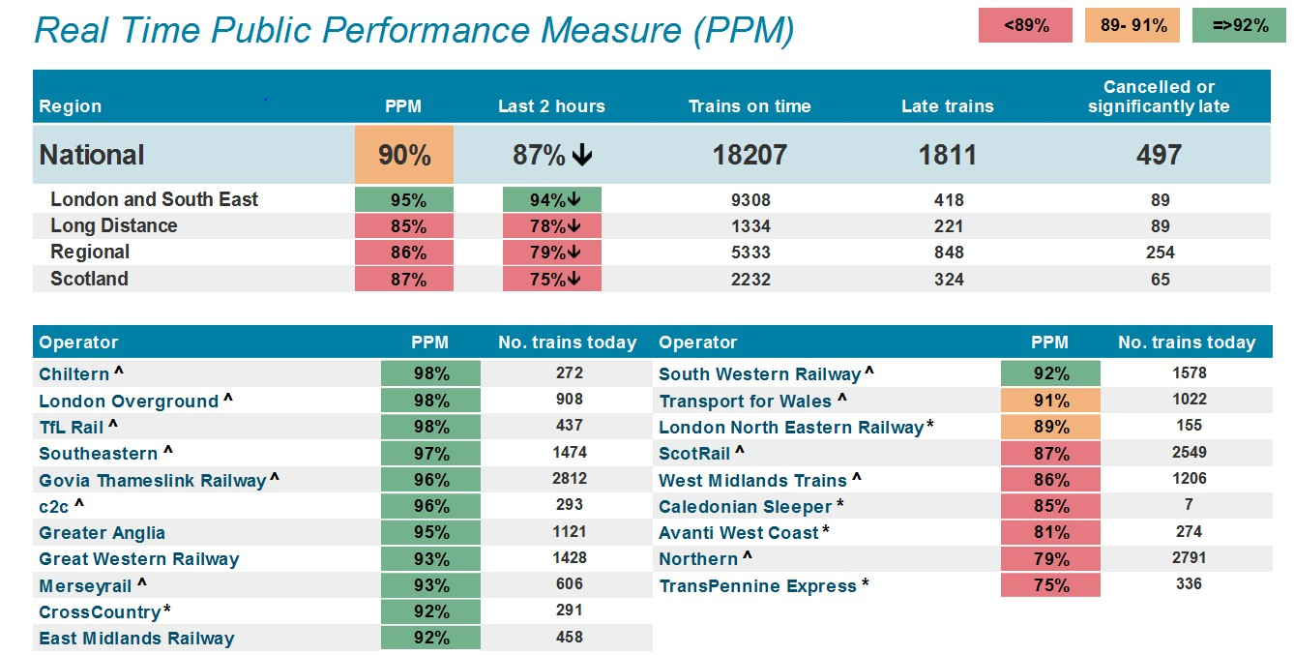

***Open Access Operators***



